***htaccess URL rewrite rule***

1) Create 2 File file.php,index.php in **htaccess_rewrite_url** project

I want to get allow in index.php parameter(**htaccess_rewrite_url/abc/def/gf**) then write in then

Create .***htaccess***:

**RewriteEngine On**

**#not important RewriteBase every time**

**RewriteBase /htaccess_rewrite_url/**

**# ture and false file(!-f) and directory(!-d) (^-carat)**

**RewriteCond %{REQUEST_FILENAME} !-f**

**RewriteCond %{REQUEST_FILENAME} !-d**

**#htaccess_rewrite_url/abc/def/gf [QSA= Query String Append, L= Last]**

**RewriteRule ^(.*)$ index.php?url=$1 [QSA,L]**

**………(OLD URL)…….(NEW URL)……**

**Then index.php:**

**if(isset($_GET['url']))**

**{**

**echo "<pre>";**

**print_r($_GET);**

**$url = $_GET['url'];**

**$url = explode("/",$url);**

**print_r($url);**

**}**

2) Create 3 File text.php ,user.php, .htaccess in **url_rewrite_in_php** project  
  
OLD Right now our URL is: [*http://localhost:7331/url_rewrite_in_php/user.php?id=7*](http://localhost:7331/url_rewrite_in_php/user.php?id=7)

(NEW) I want to convert my URL is : : [*http://localhost:7331/url_rewrite_in_php/user/7*](http://localhost:7331/url_rewrite_in_php/user/7)

Old <a> write in text.php : <a href=’user.php?id=7’> ITEM 1 </a>

(NEW) Latest angar link in text.php: <a href=’user/7’> ITEM 1 </a>

Create .htaccess:

**RewriteEngine On**

**RewriteBase /url_rewrite_in_php/**

**RewriteRule ^user/([0-9]+)$ user.php?id=$1 [NC,L] OR**

**RewriteRule ^user/** **(\w+) $ user.php?id=$1 [NC,L] OR**

**RewriteRule ^([A_Za-z0-9-]+)/** **([A_Za-z0-9-]+) $ user.php?id=$1 [NC,L]**

3) Create 3 File text.php ,user.php, .htaccess in **url_rewrite_in_php** project  
  
(OLD)Right now our URL is: [*http://localhost:7331/url_rewrite_in_php/user.php?id=7*&cat_nam=himel](http://localhost:7331/url_rewrite_in_php/user.php?id=7&cat_nam=himel)

(NEW)I want to convert my URL is : : [*http://localhost:7331/url_rewrite_in_php/user/7/*himel](http://localhost:7331/url_rewrite_in_php/user/7/himel)

(Old) <a> write in text.php : <a href=’user.php?id=1&cat_nam=himel’> ITEM 1 </a>

(NEW)Latest angar link in text.php: <a href=’user/1/himel’> ITEM 1 </a>

Create .htaccess:

**RewriteEngine On**

**RewriteBase /url_rewrite_in_php/**

**RewriteRule ^user/([0-9]+)/ ([0-9]+)$ user.php?id=$1&cat_name=$2 [NC,L] OR**

**RewriteRule ^user/** **(\w+)/** **(\w+) $ user.php?id=$1&cat_name=$2 [NC,L]**

**RewriteRule ^user/([A_Za-z0-9-]+)/([A_Za-z0-9-]+)$ user.php?id=$1&cat_name=$2[NC,L]**

4) Create 2 Filse index.php ,news.php, .htaccess in **htaccess_rewrite_url_dot_html** project  
  
OLD Right now our URL is: [*http://localhost:7331/* ***HYPERLINK "http://localhost:7331/%20htaccess_rewrite_url_dot_html%20/news.php?id=7"*** *"http://localhost:7331/%20htaccess_rewrite_url_dot_html%20/news.php?id=7"/news.php?id=7*](http://localhost:7331/%20HYPERLINK%20%22http://localhost:7331/%20htaccess_rewrite_url_dot_html%20/news.php?id=7%22%20%22http://localhost:7331/%20htaccess_rewrite_url_dot_html%20/news.php?id=7%22/news.php?id=7)

NEW I want to convert my URL is : : [*http://localhost:7331/* ***HYPERLINK "http://localhost:7331/%20htaccess_rewrite_url_dot_html%20/news/7" htaccess_rewrite_url_dot_html***  *HYPERLINK "http://localhost:7331/%20htaccess_rewrite_url_dot_html%20/news/7"/news/7*](http://localhost:7331/%20htaccess_rewrite_url_dot_html%20/news/7)*.html*

Old <a> write in index.php : <a href= ‘news.php?id=7’> ITEM 1 </a>

NEW Latest angar link in index.php: <a href= ‘news /7.html’> ITEM 1 </a>

Create .htaccess:

**RewriteEngine On**

**#this rewritebase name not importent that is oftional**

**RewriteBase /htaccess_rewrite_url_dot_html/**

**#CLEAN URL......(^ carat) [NC = NOT CASH SENSETIVE]**

**RewriteRule ^news/([0-9]+)\.html$ news.php?id=$1 [NC,L] OR**

**RewriteRule ^news/(\w+)\.html$ news.php?id=$1 [NC,L] OR**

**RewriteRule ^([A_Za-z0-9-]+)/([A-Za-z0-9-=]+)\.html$ news.php?id=$1 [NC,L]**

**5)** Create 2 Filse index.php , file.php, .htaccess in **htaccess_rewrite_url_dot_html** project  
  
OLD Right now our URL is: [*http://localhost:7331/htaccess_rewrite_url_dot_html****/file.php?id=10&cat_id=12***](http://localhost:7331/htaccess_rewrite_url_dot_html/file.php?id=10&cat_id=12)

NEW I want to convert my URL is : : [*http://localhost:7331/*](http://localhost:7331/) ***htaccess_rewrite_url_dot_html /file/10/12.html***

Old <a> write in index.php **<a href="file.php?id=10&cat_id=12" target="_blank">FILE PAGE</a>**

Latest angar link in index.php: **<a href="file/10/12.html" target="_blank">FILE PAGE</a><br>**

Create .htaccess:

**RewriteEngine On**

**#this rewritebase name not importent that is oftional**

**RewriteBase /htaccess_rewrite_url_dot_html/**

**#[NC = Not Casesencetive]**

**#CLEAN URL......(^ carat)**

**RewriteRule ^file/([0-9]+)/([0-9]+)\.html$ file.php?id=$1&cat_id=$2 [NC,L]**

**6)** Create 2 Filse index.php , file.php, .htaccess in **htaccess_rewrite_url_dot_html** project  
  
OLD Right now our URL is: [*http://localhost:7331/htaccess_rewrite_url_dot_html****/file.php?id=10&pages=12***](http://localhost:7331/htaccess_rewrite_url_dot_html/file.php?id=10&pages=12)

NEW I want to convert my URL is : : [*http://localhost:7331/*](http://localhost:7331/) ***htaccess_rewrite_url_dot_html*** */****file/id/10/pages/12.html***

Old <a> write in index.php <a href="**file.php?id=10&pages=12**" target="_blank">FILE PAGE</a

Latest angar link in index.php: <a href**="file/id/10/pages/12.html**" target="_blank">FILE PAGE</a><br>

Create .htaccess:

**RewriteEngine On**

**#this rewritebase name not importent that is oftional**

**RewriteBase /htaccess_rewrite_url_dot_html/**

**#CLEAN URL......(^ carat)**

**RewriteRule ^file/id/([0-9]+)/** **pages/([0-9]+)\.html$ file.php?id=$1&pages=$2 [NC,L]**

**7) Only Value get:**

NEW URL: <http://localhost/htaccess_url_rewrite_blog/2010/>

New anker link = <a href='2010/'> link 1 </a>

**Create .htaccess:**

**RewriteEngine On**

**RewriteBase /htaccess_url_rewrite_blog/**

**RewriteRule ^([A-Za-z0-9-]+)/?$ get_archives_by_year.php?year=$1**

Here year=2010

8) FOUR DIGIT NUMBER OR Topic name:

URL 1: <http://localhost/htaccess_url_rewrite_blog/2222/>

URL 2: <http://localhost/htaccess_url_rewrite_blog/himel/>

Create .htaccess file:

**#multiple Rule [NC = Not Casecensitive , L= Last]**

**RewriteRule ^([0-9]{4})/?$ get_archives_by_year.php?year=$1 [NC,L]**

**RewriteRule ^([A-Za-z0-9-]+)/?$ get_archives_by_topic.php?topic_name=$1 [NC,L]**

[NB: if we get 4 digit number a a value then redirect "get_archives_by_year.php" FILE OR if we get NAME as a value then redirect "get_archives_by_topic.php" FILE ]

9)

**To redirect an old domain to a new domain:**

**Usefull link: https://www.inmotionhosting.com/support/website/redirects/setting-up-a-301-permanent-redirect-via-htaccess**

**RewriteCond %{HTTP_HOST} ^old_domain.com [NC]**

**RewriteRule ^(.*)$** [**http://www.new_domain.com/$1**](http://www.new_domain.com/$1) **[L,R=301]**

**To redirect all requests missing "www" (yes www):**

**RewriteCond %{HTTP_HOST} ^domain.com [NC]**

**RewriteRule ^(.*)$** [**http://www.domain.com/$1**](http://www.domain.com/$1) **[L,R=301]**

**To redirect all requests with "www" (no www):**

**RewriteCond %{HTTP_HOST} ^www.domain.com [NC]**

**RewriteRule ^(.*)$** [**http://domain.com/$1**](http://domain.com/$1) **[L,R=301]**

**Redirect old page to new page:**

**RewriteRule ^old-url.htm$** [**http://www.domain.com/new-url.htm**](http://www.domain.com/new-url.htm) **[NC,R=301,L]**

YouTube Tutorial: (**htaccess Crash Course** ):

**Tutorial 1:**

**i) SET Directory:**

**syntax: DirectoryIndex default.html index.html index.php**

**ii) Assigne error message(specfy as many as needed):**



**Tutorial 2:**

**iii) Enable/ Disable Directory browsing:**

**that creat error 404/403/401**



**.htaccess:**

**DirectoryIndex xyx.html (unknown directory)**

# if Error SHow AND forword error page

**ErrorDocument 404** [**http://localhost:7331/htaccess_crash_course/error/error404.php**](http://localhost:7331/htaccess_crash_course/error/error404.php)

**ErrorDocument 403** [**http://localhost:7331/htaccess_crash_course/error/error403.php**](http://localhost:7331/htaccess_crash_course/error/error403.php)

# Directory Browsing off:

**Options –Indexes**

**iv)Hide File in Directory Browsing:**



**DirectoryIndex xyx.html (wring File that not exists)**

**#Hide Files in Directory Browsing**

**IndexIgnore \***

**v) Block/Allow access IP address: (this code allow and block span website in access our site)**

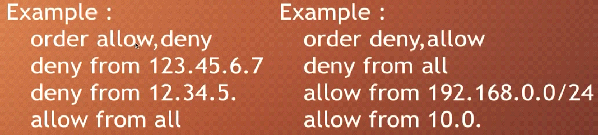

**Tutorial 3:**

**vi)RedirectURL:**



**Example: into .htaccess**

**#Creae Default Directory…**

**DirectoryIndex index.html index.php**

**# if Error SHow AND forword error page**

**ErrorDocument 404** [**http://localhost:7331/htaccess_crash_course/error/error404.php**](http://localhost:7331/htaccess_crash_course/error/error404.php)

**ErrorDocument 403** [**http://localhost:7331/htaccess_crash_course/error/error403.php**](http://localhost:7331/htaccess_crash_course/error/error403.php)

**#Hide Files in Directory Browsing**

**IndexIgnore \***

**RewriteEngine On**

**RewriteBase /htaccess_crash_course/**

**RewriteRule ^example.php$ default.html [R=301]**

**vii) Block Access from specific refer:**

(you can block span that have come from youtube or fb etc)



**viii)**

**If” mod_rewrite” is off in the ‘http_conf’ file then we must able this file in .htaccess**

**Example:**

**<ifModule mod_rewrite.c>**

**RewriteEngine On**

**RewriteRule ^example.php$ default.html [R=301]**

**</ifModule>**

**viii) Redirect Domain Name without “www” prefix:**

if your site isn’t start with **www** but user input [**www.xyz.com**](http://www.xyz.com/) then it redirect to **xyz.com**

**example:**



if your site is start with **www** but user input [**xyz.com**](http://www.xyz.com/) then it redirect to [www.**xyz.com**](http://www.xyz.com/)

**example:**



**iX) Remove index.php**

Create .***htaccess***:

**RewriteEngine On**

**#not important RewriteBase every time**

**RewriteBase /htaccess_rewrite_url/**

**# ture and false file(!-f) and directory(!-d) (^-carat)**

**RewriteCond %{REQUEST_FILENAME} !-f**

**RewriteCond %{REQUEST_FILENAME} !-d**

**#htaccess_rewrite_url/abc/def/gf**

**RewriteRule ^(.*)$ index.php?url=$1 [QSA,L]**

**Then index.php:**

**if(isset($_GET['url']))**

**{**

**echo "<pre>";**

**print_r($_GET);**

**$url = $_GET['url'];**

**$url = explode("/",$url);**

**print_r($url);**

**}**

**Tutorial: 5**

**X) Enable gZip Compression:**

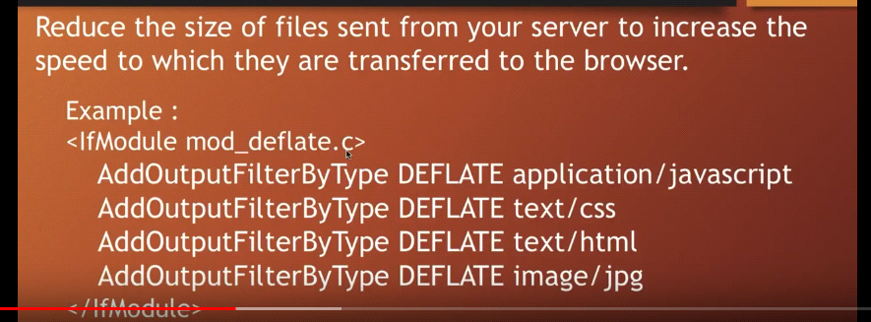

**Xi) Leverage Browser caching:**

